SAFETY ISSUES DUE TO MANUAL INSPECTION IN INDUSTRIES

FEASIBLE SOLUTIONS:
I.Robotics crawlers:
Description: Robotic crawlers are versatile, autonomous or remotely controlled robots designed to navigate through confined, hazardous, or hard-to-reach areas. They are equipped with sensors, cameras, and sometimes tools for performing inspections, monitoring, and even minor maintenance tasks.
Key Features and Benefits
1.Mobility and Flexibility
Compact Design: Designed to navigate narrow or obstructed spaces, such as pipelines, tunnels, and tanks.
Adaptable Movement: Capable of climbing, crawling, or rolling, depending on the design, allowing access to various terrains and obstacles.
2.Safety and Efficiency
Hazardous Environments: Ideal for inspecting dangerous or toxic environments without exposing human workers to risks.
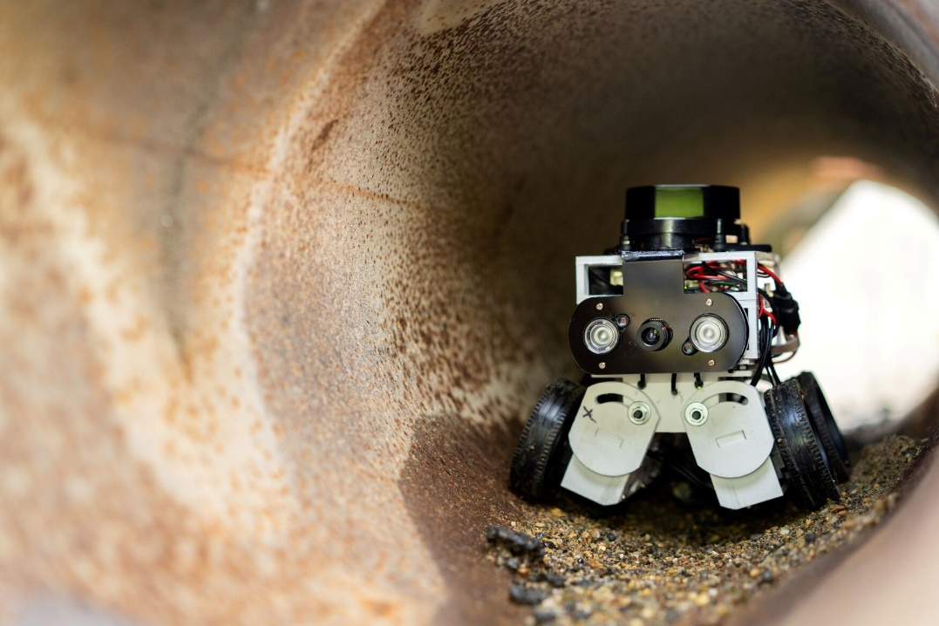

II. Camera-Based Vision Systems
Description: Camera-based vision systems use high-resolution cameras and sophisticated image processing software to capture and analyse visual data. These systems can detect defects, measure dimensions, and verify quality in real-time.
Key Components
1.Cameras
High-Resolution Cameras: Capture detailed images of the inspection area or product.
Specialized Cameras: Include thermal cameras, colour cameras, and monochrome cameras, depending on the application.
2.Display and Reporting
Monitoring Screens: Provide real-time visual feedback and analysis results.
Reporting Tools: Generate inspection reports and data logs for further analysis and record-keeping.

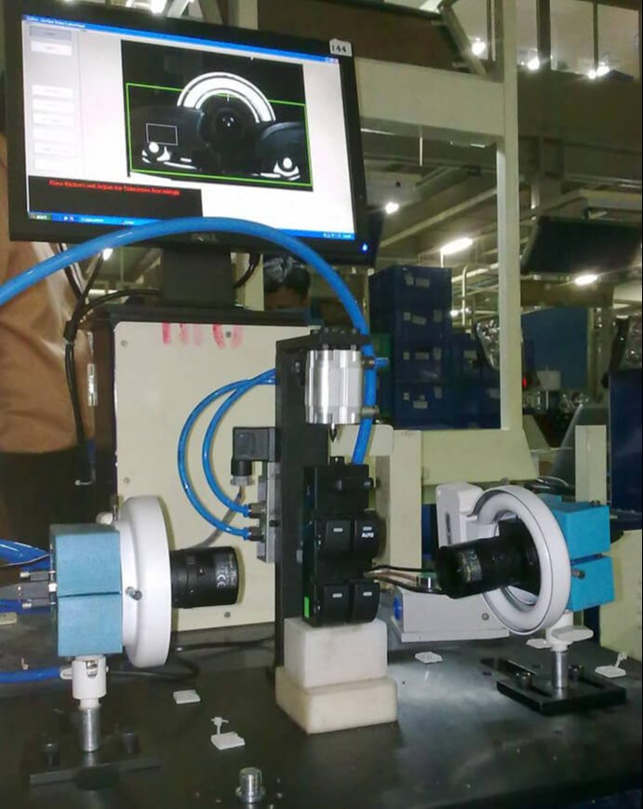

Sensor-Based Monitoring
Description: Involves using a range of sensors to continuously collect and analyse data from equipment, machinery, or environmental conditions during manual inspections. These sensors provide real-time insights that help identify issues before they escalate, enhance safety, and improve overall inspection processes.
Key Components
Visualization and Reporting Tools:- Presents data in user-friendly formats such as dashboards, charts, and graphs. Helps in understanding sensor data and making informed decisions.
Benefits:-
Reduced Human Exposure to Dangerous Environments
Function: Sensors can be deployed in hazardous environments where human presence is risky, such as confined spaces, high-temperature areas, or areas with toxic substances.
Benefit: Minimizes the need for manual inspection in dangerous conditions, thereby enhancing safety for personnel.
Automated Monitoring and Alerts
Function: Automated sensors provide continuous monitoring and generate alerts if parameters exceed safe thresholds.
Benefit: Automated alerts reduce reliance on manual inspections, ensuring that potential issues are addressed quickly and reducing the risk of oversight.
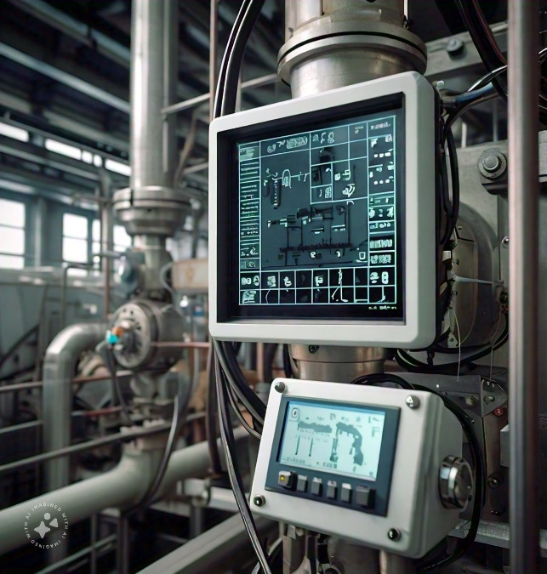
IoT Sensors for Safety in Industries:
Description
IoT (Internet of Things) sensors are advanced technological devices embedded with capabilities to monitor, collect, and transmit data regarding various parameters critical to safety in industrial environments. They address the limitations of manual inspections by providing continuous, real-time data and automation that enhance safety, efficiency, and compliance.
1. Real-Time Data Collection and Monitoring
Function: IoT sensors are deployed across industrial sites to continuously gather data on key safety metrics such as temperature, humidity, gas concentrations, equipment vibrations, and worker health.
Purpose: This constant monitoring allows for the immediate detection of any anomalies or unsafe conditions that could pose risks to personnel or equipment.
Example: A gas leak detector installed in a chemical plant continuously measures gas concentrations in the air and alerts personnel if levels exceed safe thresholds.
2. Automated Alerts and Notifications
Function: When IoT sensors detect conditions that breach predefined safety limits, they automatically generate alerts and notifications.
Purpose: These alerts are sent in real-time to safety managers and relevant personnel through mobile apps, emails, or integrated systems, enabling rapid response to potential hazards.
Example: A vibration sensor on machinery sends an alert if vibrations exceed normal ranges, indicating a possible mechanical failure.
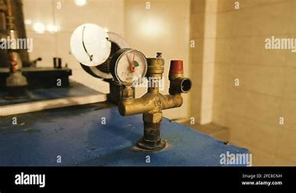

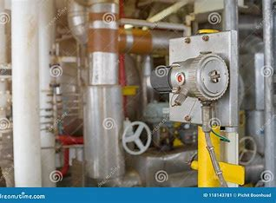

Drone-Based Inspection for Safety Issues
Description:
Drone-based inspection leverages unmanned aerial vehicles (UAVs) equipped with cameras and sensors to conduct inspections and monitor industrial sites. This modern approach enhances safety, efficiency, and accuracy compared to traditional manual inspection methods. Drones are particularly effective for accessing hard-to-reach areas and capturing detailed data in real-time, which is crucial for identifying and addressing safety issues.
Key Aspects of Drone-Based Inspection:
1.Advanced Aerial Surveillance
Function: Drones fly over and capture high-resolution images or videos of large areas or structures, providing a bird’s-eye view that is difficult to achieve with manual inspections.
Purpose: To monitor extensive infrastructure, machinery, or environmental conditions from a safe distance, improving the visibility and accessibility of hard-to-reach areas.
Example: Inspecting the exterior of a tall building or the top of a wind turbine.
2.Real-Time Data Transmission
Function: Drones transmit live video feeds and sensor data back to operators on the ground.
Purpose: Enables immediate analysis of conditions and allows for quick decision-making and responses to any detected anomalies or safety hazards.
Example: Real-time video of a chemical plant’s storage tanks showing potential leaks.
